

SYSTEMS DIVISION

PROJECT CHARTER

CTM Rewrite - Enhanced Firm Interfaces
Document #2743
WR #2743

Revised Date: February 25, 2003

Prepared by:
Maureen Smith

Approved by:

Tom Knorring
Trading Operations

Mark Novak
Systems Division

APPROVED

CTM Rewrite - Enhanced Firm Interfaces – Project Charter Distribution List

Staff
Steve Chodash
Bruce Currie
Chris DeGreef

Sandy Elliott
Todd Furney
David Glover
Gary Grant
Ed Horvath
Charlie Hullihan
Darlene Kijewski
Tom Knorring
Indravadan Merai
Jim Moss
Jim Neceda
Mark Novak
Hugh O’Neil
Bob Peterson
Larry Pfaffenbach
Nigel Phillips
Bobbie Piwnicki
Gautam Roy
Brad Samuels
Curt Schumacher
Jeff Schweitzer
Patrick Sexton
Eileen Smith
Maureen Smith
Mike Todorofsky
Stella Ulyanov
Jerome Williams
Kerry Winters
Mark Woyna

CTM Rewrite - Enhanced Firm Interfaces

Table of Contents

1. Goal 5
2. Objective 5
3. Business Case 5
4. Strategy 5
5. Tactics Statement 5
6. Project Scope and Approach 6
7. Assumptions and Issues 7
8. Risk/Exposure 7
9. Cost Analysis 8
10. Benefits 8
11. Environmental Analysis 8
12. Schedule and Dependency Constraints 8
13. Resource Skill Needs 8
14. Product Research 9

CTM Rewrite - Enhanced Firm Interfaces
PROJECT CHARTER

Goal
The goal is to reduce operating expenses by the elimination of CBOE Trade Match (CTM) interfaces dependent on the MVS operating environment. This project represents the last phase of development for migrating CTM off of the MVS operating environment. Full benefit of this project is realized when all of the firms have migrated to the new platform.

Objective
The objective of this project is to enhance firm interfaces to provide flexible, efficient access to trade data.

Business Case
The CTM Rewrite Project, WR #2213, will reduce the dependency on the MVS operating environment by migration of the CTM core system to a UNIX based platform. The strategy for the CTM Rewrite Project, WR #2213, was to reduce this dependency on the MVS operating environment without impact to the current Firm interfaces.

There are currently three methods that the firms electronically interface with CBOE through the MVS environment: RTC, 3270 ITP Terminal, and RJE/NJE data transmission. The Enhanced Firm Interfaces Project expands on the CTM Rewrite Project, and further reduces the dependency on the MVS operating environment by eliminating these dependencies on MVS and providing the firms with interfaces to CTM through a new architectural approach.

Strategy
The strategy for this project is to develop the CTM Rewrite – Enhanced Firm Interfaces project through a phased development approach. The phases will allow CBOE to move the firm interfaces off the mainframe thereby reducing the mainframe costs while gradually migrating the interfaces to a new technology consistent with the CTM core system. The functionality to be provided through this project will use the information currently provided to the firms from the CTM system as the foundation. The approach for this project is to provide the following enhancements in the new CTM interfaces architecture.

- Enhanced reporting through real-time data delivery.
- Secure access to trade match information through a Web based interface.
- Flexibility to allow the Firms format choices to receive trade match information.
- Flexibility to allow the firms data delivery choices (i.e. real-time delivery, batch delivery or both).

Tactics Statement
Project development will follow standard Systems Development Methodology.

Project Scope and Approach
The development for the CTM Rewrite Enhanced Firm Interfaces will be implemented in the following phases:

CTM Rewrite Front-End Phase 1
- Trade data delivery will be provided in multiple forms with flexibility of choice by the firms. Some such forms are:
  - A web-based access to trade information from off the trading floor.
  - Data delivery via an API in RTC IP message format.
  - Data delivery via FTP.
  - Internal direct connection for access from the CBOE trading floor.
- Enhanced capabilities will be made available allowing firms real-time access for the ability to:
  - Receive electronic trade notifications.
  - Make corrections / additions.
- Flexibility will be provided to allow firms to search and sort data by selected information (i.e. by firm, product, date, time, expiration month, acronym, products going ex-dividend, etc.).
- Security will be deployed so that firms provide authorization for access to their data. This security will be implemented with configuration options allowing the firm to limit access to query vs. update.
- Brokers will have access to trade data to assign and update CMTA’s and non-critical data.
- Data will be retained and historical access will be made available for “n” weeks.
- The ability to download data for use by PC products such as an Excel Spreadsheet enabling the firm to balance with internal bookkeeping systems.
- The ability to route information displayed to a locally attached or network printer.

CTM Rewrite Front-End Phase 2
- Enhanced capabilities will be made available allowing firms further real-time access for the ability to:
  - View unmatched advisory data.
  - Change advisories to a trade.
- Early warning alerts based on specified thresholds will provide improved monitoring. For example, identification of the percent of outtrades per firm, an indication that a firm has not submitted trades within a specified timeframe, etc.

CTM Rewrite Front-End Phase 3
- Enhanced capabilities will be made available allowing firms further real-time access. These capabilities will be determined during the requirements phase of the project..
- Messaging system providing:
  - Instant messaging capability.
  - CBOE current events distributed via global broadcast.
  - Directed message distribution.
  - Access to the messaging system to be provided to firms and CBOE Help Desk.

Assumptions and Issues
Assumptions
- It is assumed that CBOEdirect domain experts will be available on an as-needed basis.
- CTMR domain experts will be available on an as-needed basis.
- The DOSS group will install and configure Linux on the production server hardware.
- An Object Architect will provide in-house Foundation Framework Training.
- As part of the detailed requirements process, the Object Architect will participate in identifying new services as well as extensions to existing business services.
- Requires firms to migrate from LU6.2 to RTC IP.

Issues
- An open issue exists regarding the security access for allowing users to access and modify data via an Internet connection. These issues will be reviewed during the requirements phase of the project.
- Delivery of data via a FIX API will require review during the requirements phase of the project to determine if entry of trade data is a provided format.

Risk/Exposure
The technology risk for this project is medium. There are several new technologies being introduced into the production Trade Match environment. These include CORBA, Linux, Web Services and CBOEdirect Foundation Framework. CBOEdirect Foundation Framework and CORBA have been in production for several years. Using this technology is controllable given the participation of experienced CBOEdirect staff on this project.

Cost Analysis

Development Costs Phase 1
System | Con Man-Months | Rate Per Con Month | Con Cost | Staff Man-Months | Rate Per Staff Month | Staff Cost | Total Cost
CTM Development | 12 | $15,000 | $180,000 | 34 | $ 8,900 | $302,600 | $482,600
Internet/Intranet |  |  |  | 3 | $ 8,900 | $26,700 | $26,700
CTM-R Development |  |  |  | 6 | $ 8,900 | $53,400 | $53,400
Hardware Software  9 Pentium Servers (6 prod, 3 dev) @$5,000/ea |  |  |  |  |  |  | $45,000
Total Phase 1 | 12 |  | $180,000 | 43 |  | $382,700 | $607,700

Development Costs Phase 2
System | Staff Man-Months | Rate Per Staff Month | Staff Cost | Total Cost
CTM Development | 10 | $ 8,900 |  | $89,000
CTM-R Development | 4 | $ 8,900 |  | $35,600
Total Phase 2 | 14 |  |  | $124,600

Development Costs Phase 3
System | Staff Man-Months | Rate Per Staff Month | Staff Cost | Total Cost
CTM Development | 10 | $ 8,900 |  | $89,000
Total Phase 3 | 10 |  |  | $89,000

Total Costs Phase 1 - 3
Phase | Con Cost | Staff Cost | Total Cost
Phase 1 | $180,000 | $382,700 | $562,700
Phase 2 |  | $124.600 | $123,600
Phase 3 |  | $89,000 | $89,000
Hardware Software |  |  | $45,000
Total Costs |  |  | $820,300

Benefits
The benefit of this project is an opportunity to reduce operating expenses dependent on MVS as firms migrate to the new approach. An added benefit is an improved interface for firms to manage post trade data.

Environmental Analysis – See attachment 1 – Architectural Diagram
The following are new architectural components for the CTM Rewrite – Enhanced Firm Interface project:
- Browser in Internet Explorer
- Presentation uses STRUTS framework (tag libraries written in JSP and HTML)
- Web server is Jetty
- Application server is CBOE Foundation Framework
- Application server operating system is Linux

Tools and software are:
- Eclipse (IDE for JAVA and JSP)
- STRUTS libraries (JAVA code to support the STRUTS framework)
- SDK version 1.4.1
- Dreamweaver (HTML Editor)
- ClearCase (source archive for Web applications)

Hardware:
- Dual processor Intel based servers running Linux.

Schedule and Dependency Constraints
This project is dependent on the completion of the CTM-Rewrite project WR #2213 and the prioritization established by the Systems Committee.

Resource Skill Needs
In-house resources have the skills necessary to complete the CTM Rewrite - Enhanced Firm Interfaces Project.

Product Research
No further investigation of products or vendors will be necessary to complete the CTM Rewrite – Enhanced Firm Interfaces Project.

Attachment 1 - Architectural Diagrams
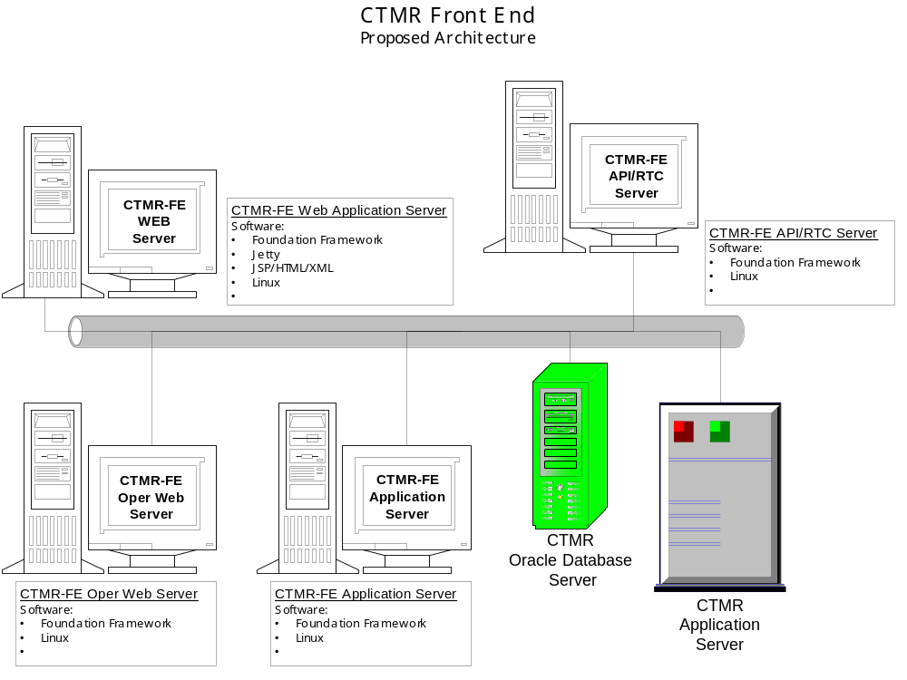
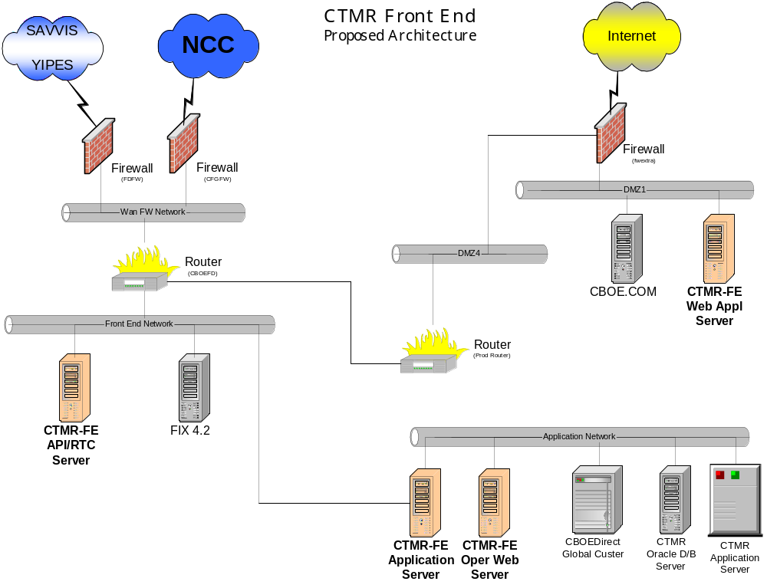

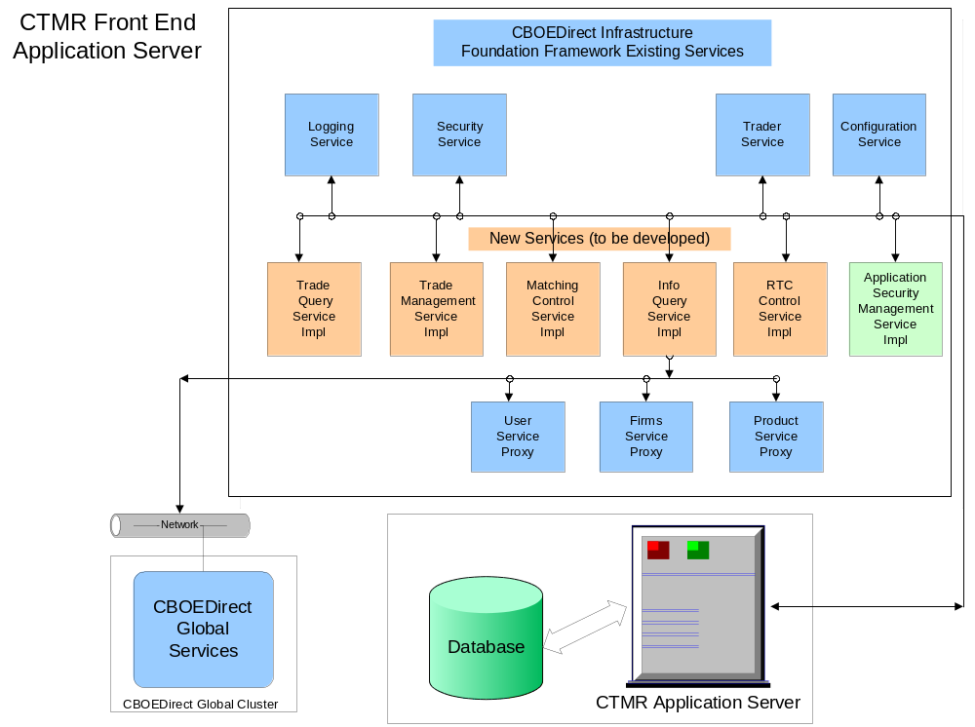

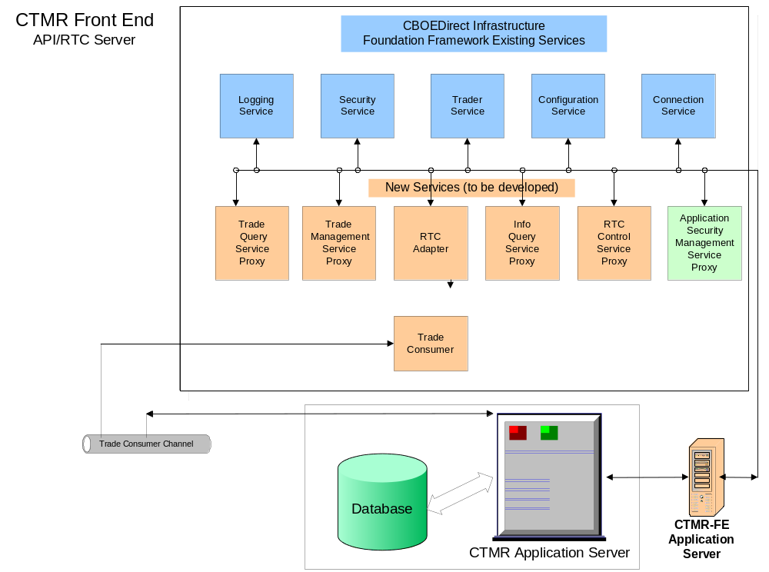

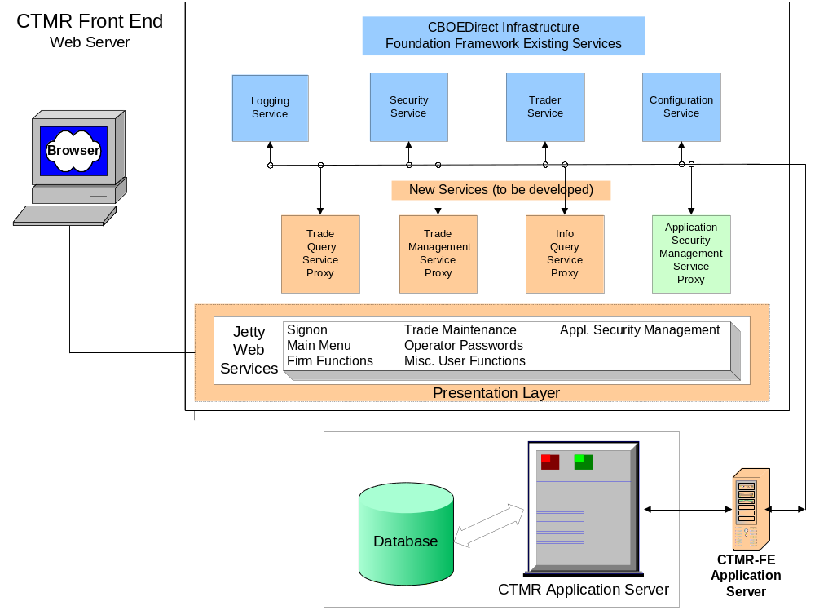
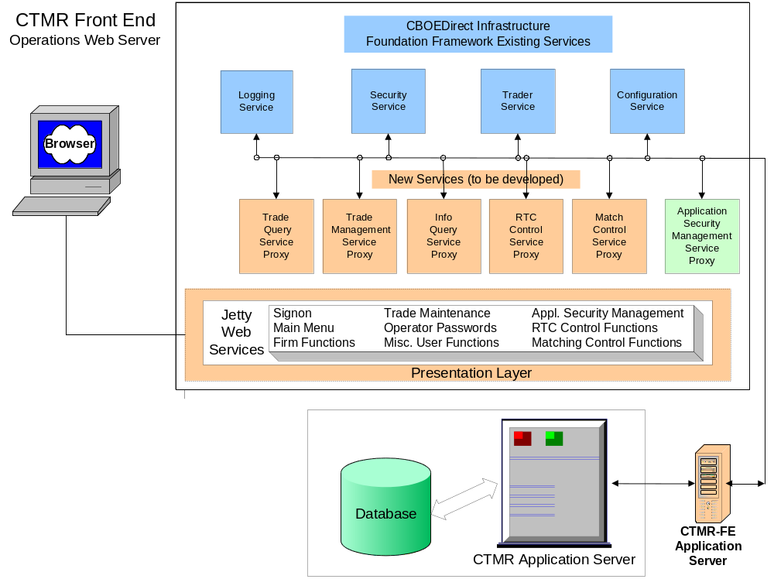

The project was included in the FY04 budget. Phase 2 & 3 estimates are for staff only.

